**Progress Report**

# **Data Analysis and Image Quality Analysis**

## **Removed redundant files**

The provided Python script is designed to synchronize two folders—one containing image files and the other containing text files—by removing redundant files from each directory. The goal is to ensure that every image file has a corresponding text file and vice versa. Here's a detailed breakdown of how the script achieves this:

**Remove Redundant Image Files:**

The script iterates through the list of image files, generating a standardized ID for each. It checks if the standardized ID is present in the set of text file identifiers. If an image ID does not have a corresponding text ID, the image file is removed from the folder. A message is printed for each removed image file to indicate the deletion.

**Remove Redundant Text Files:**

The script iterates through the list of text files, generating an ID for each text file. It checks if the text ID is present in the set of image file identifiers.If a text ID does not have a corresponding image ID, the text file is removed from the folder. A message is printed for each removed text file to indicate the deletion.

**Purpose**

The script helps ensure consistency between the two folders by removing files that do not have corresponding counterparts in the other folder. This is useful in scenarios where images and their associated text files need to be kept in sync, such as in data preprocessing for machine learning or image annotation tasks.

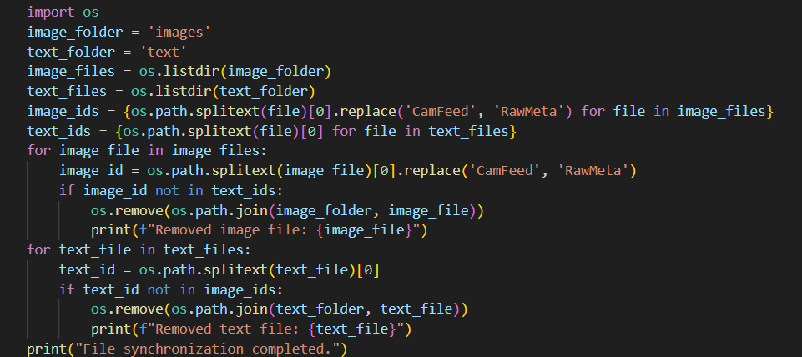

## Renaming files

The purpose of the script is to rename .png files in a specified directory by appending a new base name and a sequence number to each file. This helps to organize and distinguish files, especially when combining files from different folders with identical names.

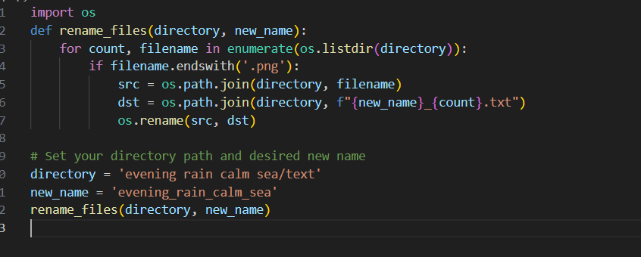

## checking dataset

The purpose of this script is to count and display the number of files in specified directories for both images and labels across training, validation, and testing datasets. It helps in verifying the organization and completeness of the dataset by listing the number of files in each class directory within these datasets.

## making separate folders

## maximum supression to remove redundant bounding boxes

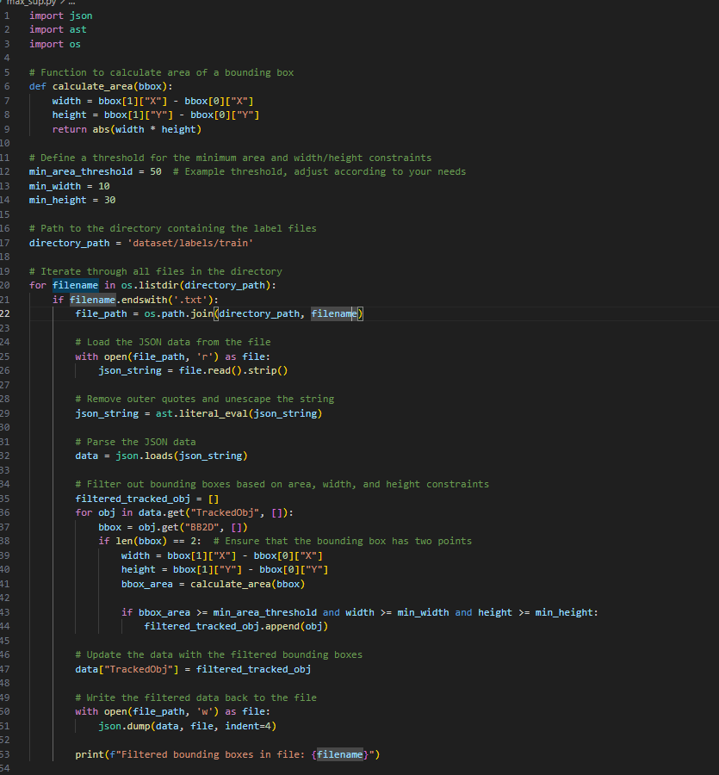

## reshaping 1280x720 into 640x640

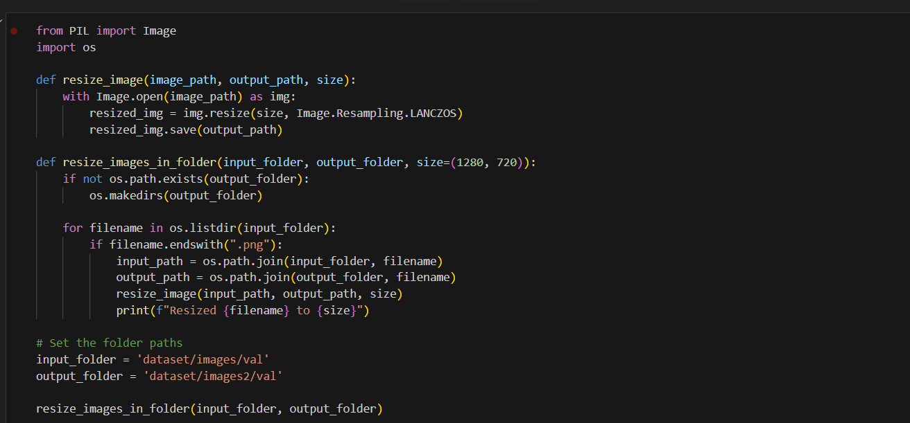

# Exploratory data analysis

**Exploratory Data Analysis (EDA)** is a crucial step in understanding the characteristics of your dataset. It involves using statistical methods and visualizations to gain insights into the data's structure, relationships, and anomalies.

**a. Data Distribution Analysis:**

* **Histograms:** Used to visualize the distribution of numerical data. They show the frequency of data points within specified ranges (bins). Histograms help identify the shape of the data distribution (e.g., normal, skewed, bimodal).
* **Box Plots:** Useful for visualizing the spread and skewness of the data. Box plots highlight the median, quartiles, and potential outliers. They are particularly effective for comparing distributions across different categories.

**b. Correlation Analysis:**

* **Correlation Matrix:** A table showing correlation coefficients between variables. Values range from -1 to 1, indicating the strength and direction of relationships between variables. Positive values indicate positive correlation, while negative values indicate negative correlation.

**3. Generate Descriptive Statistics and Visualizations**

**Descriptive Statistics** provide a summary of the dataset's key characteristics through numerical measures.

**a. Measures of Central Tendency:**

* **Mean:** The average value of a dataset, calculated by summing all data points and dividing by the number of points. It provides a central value but can be affected by outliers.
* **Median:** The middle value when data points are sorted in ascending order. It is less sensitive to outliers compared to the mean and provides a better measure of central tendency for skewed distributions.
* **Mode:** The most frequently occurring value in the dataset. In some cases, there may be more than one mode.

**b. Measures of Dispersion:**

* **Variance:** Measures the average squared deviation from the mean, indicating the spread of data points. Higher variance means greater dispersion.
* **Standard Deviation:** The square root of variance, providing a measure of spread in the same units as the data. It is easier to interpret than variance.
* **Range:** The difference between the maximum and minimum values in the dataset. It gives a sense of the total spread but is sensitive to outliers.

**c. Visualizations:**

* **Histograms:** Display the frequency distribution of numerical data.
* **Scatter Plots:** Show the relationship between two continuous variables. Useful for identifying trends, correlations, and clusters.
* **Box Plots:** Highlight the distribution and potential outliers of the data.

**4. Implement Algorithms to Assess Image Quality Factors**

Assessing image quality involves evaluating various attributes to determine how well an image meets quality standards. Common quality factors include sharpness, contrast, noise, and lighting conditions.

**a. Sharpness:**

**Laplacian Variance:** Computes the variance of the Laplacian of the image. Higher variance indicates higher sharpness, while lower variance suggests blurriness.

**b. Contrast:**

* **Histogram Analysis:** Analyzing the histogram of pixel intensities can help assess contrast. A well-contrasted image has a wide range of pixel values, while a low-contrast image has a narrow range.
* **Contrast Ratio:** Measures the difference in intensity between the brightest and darkest areas of the image. This can be computed using metrics like the RMS contrast.

**c. Noise:**

* **Noise Estimation Algorithms:** Methods such as the Wiener filter or median filtering can be used to estimate and reduce noise. Image noise is often characterized by random variations in pixel intensity.
* **Signal-to-Noise Ratio (SNR):** Measures the ratio of the signal strength (useful information) to the noise level. Higher SNR indicates better image quality with less noise.

**d. Lighting Conditions:**

* **Exposure Analysis:** Evaluates if the image is overexposed or underexposed by analyzing pixel intensity distributions. Properly exposed images should have a balanced histogram without significant clipping at the extremes.
* **Dynamic Range:** Assesses the range of pixel intensities from the darkest to the lightest areas. Images with a wider dynamic range typically have better lighting conditions.

**Summary**

* **Exploratory Data Analysis (EDA)** involves visualizing data distributions, analyzing correlations, and detecting outliers to understand the dataset's characteristics.
* **Descriptive Statistics and Visualizations** provide numerical summaries and graphical representations of the data, including measures of central tendency, dispersion, and various plots.
* **Image Quality Assessment** includes implementing algorithms to evaluate sharpness, contrast, noise, and lighting conditions, using techniques such as edge detection, histogram analysis, and noise estimation.

These steps provide a comprehensive approach to understanding and improving both datasets and images, helping in making data-driven decisions and ensuring high-quality outputs

## data distributions

import os

import json

import ast

import pandas as pd

import matplotlib.pyplot as plt

import seaborn as sns

from PIL import Image

sub_dirs = ['cloudy and medium wave', 'evening calm', 'evening rain calm sea', 'foggy and calm sea']

image_data = []

annotation_data = []

for sub_dir in sub_dirs:

    image_dir = os.path.join(sub_dir, 'images')

    text_dir = os.path.join(sub_dir, 'text')

    for text_file in os.listdir(text_dir):

        if text_file.endswith('.txt'):

            text_path = os.path.join(text_dir, text_file)

            with open(text_path, 'r') as f:

                json_string = f.read().strip()

            json_string = ast.literal_eval(json_string)

            annotation = json.loads(json_string)

        annotation_data.append(annotation)

            image_file = text_file.replace('RawMeta', 'CamFeed').replace('.txt', '.png')

            image_path = os.path.join(image_dir, image_file)

            if os.path.exists(image_path):

                image_data.append(image_path)

rows = []

for annotation in annotation_data:

    for obj in annotation['TrackedObj']:

        for bb in obj['BB2D']:

            rows.append({

                'ObjectName': obj['ObjectName'],

                'Alias': obj['Alias'],

                'X': bb['X'],

                'Y': bb['Y']

            })

annotations_df = pd.DataFrame(rows)

print(annotations_df.info())

print(annotations_df.describe())

print(annotations_df.isnull().sum())

### output

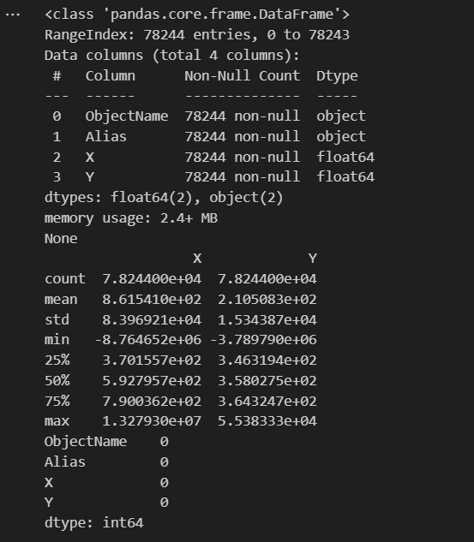

bbox_counts = annotations_df.groupby(['ObjectName', 'Alias']).size().reset_index(name='bbox_count')

plt.figure(figsize=(10, 6))

sns.histplot(bbox_counts['bbox_count'], bins=20, kde=True)

plt.title('Distribution of Bounding Box Counts per Object')

plt.xlabel('Number of Bounding Boxes')

plt.ylabel('Frequency')

plt.show()

from PIL import ImageDraw, ImageFont

def plot_image_with_bboxes(image_path, tracked_objects):

    image = Image.open(image_path)

    width, height = image.size

    draw = ImageDraw.Draw(image)

    font = ImageFont.load_default()

    for obj in tracked_objects:

        alias = obj['Alias']

        bbox = obj['BB2D']

        if len(bbox) >= 2:

            x1 = max(0, min(width - 1, bbox[0]['X']))

            y1 = max(0, min(height - 1, bbox[0]['Y']))

            x2 = max(0, min(width - 1, bbox[1]['X']))

            y2 = max(0, min(height - 1, bbox[1]['Y']))

            draw.rectangle([x1, y1, x2, y2], outline="red", width=3)

            label = alias

            draw.rectangle([x1, y1 - 10, x1 + len(label) * 6, y1], fill="red")

            draw.text((x1, y1 - 10), label, font=font, fill="white")

    plt.imshow(image)

    plt.axis('off')

    plt.show()

for i in range(min(5, len(image_data))):

    plot_image_with_bboxes(image_data[i], annotation_data[i]['TrackedObj'])

## plotting bounding boxes

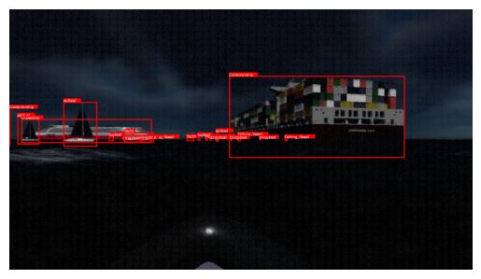

## corelation

import seaborn as sns

import matplotlib.pyplot as plt

numeric_df = df.select_dtypes(include=[float, int])

    # Correlation matrix

    corr_matrix = numeric_df.corr()

    plt.figure(figsize=(10, 8))

    sns.heatmap(corr_matrix, annot=True, cmap='coolwarm', vmin=-1, vmax=1)

    plt.title('Correlation Matrix')

    plt.show()

    # Outliers detection using box plots

    plt.figure(figsize=(12, 8))

    sns.boxplot(data=numeric_df)

    plt.title('Box Plot of Numeric Columns')

    plt.xlabel('Numeric Columns')

    plt.ylabel('Value')

    plt.show()

# Perform the analysis on the annotations DataFrame

analyze_correlations_and_outliers(annotations_df)

# image quality factors

import cv2

import numpy as np

import os

import pandas as pd

from matplotlib import pyplot as plt

def compute_sharpness(image):

    gray_image = cv2.cvtColor(image, cv2.COLOR_BGR2GRAY)

    laplacian_var = cv2.Laplacian(gray_image, cv2.CV_64F).var()

    return laplacian_var

def compute_contrast(image):

    gray_image = cv2.cvtColor(image, cv2.COLOR_BGR2GRAY)

    rms_contrast = np.sqrt(np.mean(gray_image**2))

    return rms_contrast

def compute_noise(image):

    gray_image = cv2.cvtColor(image, cv2.COLOR_BGR2GRAY)

    noise_std = np.std(gray_image)

    return noise_std

def compute_lighting(image):

    gray_image = cv2.cvtColor(image, cv2.COLOR_BGR2GRAY)

    mean_brightness = np.mean(gray_image)

    return mean_brightness

def analyze_image_quality(root_folder):

    metrics = []

    for subdir, _, files in os.walk(root_folder):

        for filename in files:

            if filename.endswith(('.png', '.jpg', '.jpeg')):

                image_path = os.path.join(subdir, filename)

                image = cv2.imread(image_path)

                if image is not None:

                    sharpness = compute_sharpness(image)

                    contrast = compute_contrast(image)

                    noise = compute_noise(image)

                    lighting = compute_lighting(image)

                    metrics.append({

                        'folder': subdir,

                        'filename': filename,

                        'sharpness': sharpness,

                        'contrast': contrast,

                        'noise': noise,

                        'lighting': lighting

                    })

    metrics_df = pd.DataFrame(metrics)

    return metrics_df

root_folder = 'cloudy and medium wave/images'

image_metrics_df = analyze_image_quality(root_folder)

image_metrics_df.to_csv('image_quality_metrics.csv', index=False)

print(image_metrics_df)

fig, axes = plt.subplots(2, 2, figsize=(15, 10))

axes[0, 0].hist(image_metrics_df['sharpness'], bins=20, color='skyblue')

axes[0, 0].set_title('Sharpness Distribution')

axes[0, 1].hist(image_metrics_df['contrast'], bins=20, color='lightgreen')

axes[0, 1].set_title('Contrast Distribution')

axes[1, 0].hist(image_metrics_df['noise'], bins=20, color='salmon')

axes[1, 0].set_title('Noise Distribution')

axes[1, 1].hist(image_metrics_df['lighting'], bins=20, color='orange')

axes[1, 1].set_title('Lighting Distribution')

plt.tight_layout()

plt.show()

# 1. Ensemble Learning for Object Detection

**Ensemble Learning** involves combining multiple models to improve performance. For object detection, this typically means combining different models or the same model trained with different parameters. Here's a detailed look at how ensemble learning can be used:

## Approaches:

1. **Model Averaging:**
   * **Description:** Multiple object detection models are trained independently, and their predictions are averaged or voted upon to make the final decision.
   * **Example:** Suppose you have three different object detection models (e.g., Faster R-CNN, YOLO, SSD). After training, you can average their bounding box predictions and confidence scores to get a more robust detection.
2. **Stacking:**
   * **Description:** This involves training a "meta-learner" model that learns how to best combine the predictions from multiple base models.
   * **Example:** You might use predictions from several object detectors as input features for a second-level model that learns to weigh the contributions of each base model to improve accuracy.
3. **Bagging:**
   * **Description:** Different subsets of the training data are used to train multiple models, and the predictions are aggregated.
   * **Example:** You can train several object detection models on different subsets of your dataset and then combine their outputs to improve detection robustness.

**Benefits:**

* **Improved Accuracy:** Combining models can lead to better performance than individual models, especially when different models have complementary strengths.
* **Robustness:** Ensembles can reduce the risk of overfitting and make the system more robust to variations in data.

**Challenges:**

* **Increased Computational Cost:** Training and running multiple models can be resource-intensive.
* **Complexity:** Combining predictions and managing ensemble models can add complexity to the deployment pipeline.

# 2. Neural Architecture Search (NAS) for Object Detection

**Neural Architecture Search (NAS)** involves automatically searching for the best neural network architecture for a given task. For object detection, NAS can be used to optimize architectures to improve performance.

**Approaches:**

1. **Search Space Definition:**
   * **Description:** Define the range of possible architectures that NAS will explore. This includes choices for layer types, numbers of layers, filter sizes, and so on.
   * **Example:** For object detection, the search space might include different backbone networks (e.g., ResNet, MobileNet), anchor box configurations, and detection heads.
2. **Search Algorithms:**
   * **Reinforcement Learning (RL):** Uses RL to explore different architectures by treating architecture design as a sequential decision-making problem.
     + **Example:** An RL agent explores different network configurations, receives feedback based on detection performance, and adjusts the search strategy accordingly.
   * **Evolutionary Algorithms:** Uses evolutionary strategies to evolve architectures over generations based on their performance.
     + **Example:** Architectures are mutated and recombined, and the best-performing designs are kept and further evolved.
   * **Gradient-based Methods:** Utilize gradient descent to optimize architecture parameters.
     + **Example:** Techniques like DARTS (Differentiable Architecture Search) use gradient-based optimization to find the best architecture in a continuous space.

**Benefits:**

* **Optimized Architectures:** NAS can discover novel architectures that are tailored to the specific requirements of the object detection task.
* **Automated Design:** Reduces the need for manual tuning and experimentation with network designs.

**Challenges:**

* **Computationally Expensive:** NAS can be very resource-intensive due to the large number of architectures that need to be evaluated.
* **Complexity:** The search process can be complex, requiring careful tuning of search algorithms and performance estimation.

**Combining Ensemble Learning and NAS**

Combining ensemble learning with NAS can potentially yield very powerful object detection systems. Here's how:

* **NAS to Optimize Base Models:** Use NAS to discover optimal architectures for individual object detection models, and then combine these models in an ensemble.
* **Ensemble of NAS-Designed Models:** Create an ensemble of multiple architectures found through NAS, potentially leveraging their diverse strengths.

Overall, both ensemble learning and NAS represent advanced techniques that can significantly enhance object detection performance, though they come with their own sets of challenges and computational requirements.

# Other advanced techniques

## 1. Attention Mechanisms

**Attention Mechanisms** improve the model's ability to focus on relevant parts of an image.

* **Spatial Attention:** Helps the model focus on specific regions of the image, enhancing its ability to detect objects in cluttered scenes.
* **Channel Attention:** Focuses on important feature channels, which can improve the representation of object features.

## 2. Feature Pyramid Networks (FPNs)

**Feature Pyramid Networks (FPNs)** are used to build high-level semantic feature maps at different scales.

* **Multi-scale Detection:** FPNs allow the model to detect objects at various scales by combining low-level and high-level features.
* **Enhanced Feature Representation:** Improves the detection of small and large objects by leveraging features from different layers.

## 3. Region-based Techniques

**Region-based Techniques** focus on improving object localization and classification.

* **Region Proposal Networks (RPNs):** Used in frameworks like Faster R-CNN to generate object proposals that are then refined for final detection.
* **Region-based Attention:** Incorporate attention mechanisms within the region proposals to better focus on the object of interest.

## 4. Multi-task Learning

**Multi-task Learning** involves training a model to perform multiple related tasks simultaneously.

* **Joint Detection and Segmentation:** Train the model to perform both object detection and semantic segmentation, which can improve object localization and boundary accuracy.
* **Auxiliary Tasks:** Include additional tasks like object pose estimation or attribute prediction to enrich the model's understanding of the objects.

## 5. Data Augmentation

**Data Augmentation** techniques enhance the training dataset with variations to improve model robustness.

* **Geometric Transformations:** Apply transformations such as rotation, scaling, and flipping.
* **Photometric Transformations:** Adjust brightness, contrast, and color to simulate different lighting conditions.
* **Synthetic Data Generation:** Use tools like 3D rendering or GANs to create additional training examples.

## 6. Few-Shot and Zero-Shot Learning

**Few-Shot and Zero-Shot Learning** aim to handle scenarios where only limited or no labeled examples are available for certain classes.

* **Few-Shot Learning:** Use techniques such as meta-learning or prototypical networks to recognize objects from a few examples.
* **Zero-Shot Learning:** Leverage semantic embeddings or auxiliary information to recognize objects from classes with no labeled data.

## 7. Anchor-Free Methods

**Anchor-Free Methods** aim to simplify the detection process by eliminating the need for predefined anchor boxes.

* **CenterNet:** Detect objects by predicting the center points and sizes directly, rather than using anchor boxes.
* **FCOS (Fully Convolutional One-Stage Object Detection):** Predict object centers and bounding boxes without relying on anchor boxes.

## 8. Graph-Based Approaches

**Graph-Based Approaches** use graph structures to capture relationships between objects.

* **Graph Neural Networks (GNNs):** Model relationships between different objects or parts of objects, improving detection in complex scenes with multiple objects.
* **Relation Networks:** Enhance object detection by explicitly modeling relationships between detected objects.

## 9. Hybrid Architectures

**Hybrid Architectures** combine different techniques to leverage their strengths.

* **Two-Stage Detectors with Efficient Backbones:** Combine high-performance two-stage detection frameworks like Faster R-CNN with efficient backbones like MobileNet.
* **Integrated Detection and Tracking:** Combine object detection with tracking methods to improve object identification across frames in videos.

## 10. Knowledge Distillation

**Knowledge Distillation** involves training a smaller, more efficient model (student) to replicate the performance of a larger, more complex model (teacher).

* **Teacher-Student Framework:** The student model learns from the predictions of the teacher model, often leading to more efficient deployment while retaining high accuracy.

These advanced techniques can be combined in various ways depending on the specific requirements of the object detection task, such as accuracy, speed, or robustness. Each technique has its own strengths and is often used in conjunction with others to build state-of-the-art object detection systems

# Edge Computing Devices

## 1.1. Edge Devices

**NVIDIA Jetson Series:**

* **Jetson Nano:** Ideal for small-scale AI applications, it provides GPU acceleration with a low power footprint, suitable for tasks such as image classification and object detection.
* **Jetson Xavier NX:** Offers enhanced performance with 21 TOPs (Tera Operations Per Second), making it suitable for more demanding AI applications like autonomous machines and intelligent video analytics.
* **Jetson Orin:** A high-performance module delivering up to 275 TOPs, designed for complex tasks and real-time applications including high-resolution video processing and advanced AI capabilities.

**Google Coral Devices:**

* **Coral Dev Board:** Features the Edge TPU for rapid inferencing of machine learning models, ideal for tasks such as image classification and object detection with low latency.
* **Coral USB Accelerator:** A USB device that enhances existing systems by adding Edge TPU acceleration, improving inference performance for AI tasks.

**Intel Neural Compute Stick 2 (NCS2):**

* A USB stick providing neural network acceleration, compatible with various devices to boost AI inference performance using Intel’s Myriad X VPU.

**Raspberry Pi:**

* **Raspberry Pi 4:** While not as powerful as specialized AI hardware, it can be used for local inference when combined with machine learning libraries. Its versatility and affordability make it suitable for educational and prototyping purposes.

**AWS DeepLens:**

* A deep learning-enabled video camera for running models locally, with integration into AWS services for additional cloud-based processing and storage.

## 1.2. Edge Servers

**NVIDIA EGX Platform:**

* Provides high-performance computing with powerful GPUs tailored for edge applications, suitable for large-scale deployments needing real-time analytics and AI inferencing.

**Dell EMC PowerEdge XE2420:**A rugged edge server designed for high-performance edge computing, including AI and machine learning tasks, ensuring reliability in challenging environments.

# Cloud Deployment Platforms

## 2.1. Cloud Services

**Amazon Web Services (AWS):**

* **AWS Lambda:** Serverless computing service for running code in response to events, including inference requests, optimizing resource usage and scalability.
* **Amazon SageMaker:** Fully managed service for building, training, and deploying machine learning models, integrating tools for comprehensive model management.
* **AWS EC2:** Scalable compute instances, including GPU instances, for high-performance model inference and flexible resource management.

**Microsoft Azure:**

* **Azure Functions:** Serverless compute service for event-driven execution, suitable for deploying models in a serverless architecture with automatic scaling.
* **Azure Machine Learning:** Platform for training, deploying, and managing machine learning models, offering tools for experimentation and deployment.
* **Azure Virtual Machines:** Provides scalable VMs, including GPU-based instances, for intensive AI tasks and high-performance computing.

**Google Cloud Platform (GCP):**

* **Google Cloud Functions:** Serverless execution environment for running code in response to events, allowing scalable and event-driven AI model deployment.

## 2.2. Specialized Cloud AI Platforms

**IBM Watson:**

* Provides AI services such as visual recognition for tasks like object detection, with pre-built models and tools for integration into applications.

**Alibaba Cloud:**

* **Machine Learning Platform for AI (PAI):** Suite of tools for model training and deployment, offering comprehensive solutions for AI tasks.**Elastic GPU Service:** Scalable GPU-powered instances for high-performance machine learning tasks, similar to offerings from AWS and GCP.

# Hardware Acceleration

## 3.1. GPUs

**NVIDIA GPUs:**

* **NVIDIA A100 Tensor Core GPU:** High-performance GPU for data centers, optimized for AI training and inference, supporting complex computations and large-scale AI workloads.
* **NVIDIA RTX 3080/3090:** Consumer GPUs providing substantial performance for AI research and development, suitable for model training and inference.
* **NVIDIA Tesla V100:** Powerful GPU for deep learning and high-performance computing, widely used in data centers for training complex models.

## 3.2. TPUs

**Google Cloud TPU:**

* **TPU v4:** High-performance Tensor Processing Units available on Google Cloud, designed for accelerating TensorFlow operations with exceptional performance for AI tasks.

**Edge TPU:**

* **Google Coral Edge TPU:** Hardware accelerator for fast inferencing of machine learning models on edge devices, supporting real-time AI applications with low latency and power efficiency.

# Optimization Frameworks

## 4.1. Frameworks for Edge and Cloud

**TensorFlow Lite:**

* Lightweight version of TensorFlow designed for deploying machine learning models on mobile and embedded devices, optimizing for performance and efficiency on resource-constrained environments.

**ONNX Runtime:**

* Open-source cross-platform inference engine that supports models trained in multiple frameworks (e.g., PyTorch, TensorFlow), enabling efficient and flexible deployment across different platforms.

**Core ML:**

* Apple’s framework for integrating machine learning models into iOS applications, supporting a range of models with optimizations for performance on Apple devices.

**NVIDIA TensorRT:**

* Inference optimizer designed to accelerate the deployment of models on NVIDIA GPUs, offering optimizations such as precision calibration and layer fusion to enhance inference performance.

**PyArmNN:**

* A lightweight, cross-platform inference engine developed by Arm for deploying machine learning models on Arm-based devices. It supports models trained in TensorFlow and ONNX, providing optimizations for performance on edge devices and ensuring efficient execution on resource-constrained hardware.

**OpenVINO:**

* Developed by Intel, OpenVINO (Open Visual Inference and Neural network Optimization) toolkit enhances the performance of deep learning models on Intel hardware. It supports a wide range of Intel processors, including CPUs, GPUs, and FPGAs, and provides tools for optimizing and deploying models trained in frameworks like TensorFlow, Caffe, and ONNX. It is particularly useful for improving inference performance on Intel-based edge devices and servers.

By incorporating these additional optimization frameworks, such as PyArmNN and OpenVINO, organizations can further enhance the performance and efficiency of their AI deployments across various hardware platforms and environments.

# model training comparison

## RCNN (Region-based Convolutional Neural Networks)

* **Recall and Precision**: RCNN models typically have high precision but can be slower in terms of recall compared to more modern architectures. They often require a region proposal network (RPN) or external proposal methods which can be slow.
* **mAP**: RCNN models can achieve high mAP scores, particularly in well-defined benchmark datasets. However, the performance depends heavily on the implementation and additional components like Fast RCNN and Faster RCNN.
* **Inference Speed**: RCNN is known for its slower inference speed. The original RCNN involves running a CNN for each region proposal, which can be very computationally expensive.
* **Test Accuracy**: RCNN models often have high accuracy in terms of detecting objects and their boundaries but are not as fast as more modern approaches.

## SSD (Single Shot MultiBox Detector)

* **Recall and Precision**: SSD models generally offer a good balance between recall and precision. They are designed to make predictions at multiple scales, which helps in detecting objects of varying sizes.
* **mAP**: SSD models typically achieve competitive mAP scores. They perform well on standard datasets but may not reach the levels of the latest architectures in some cases.
* **Inference Speed**: SSD is faster than RCNN models due to its single-shot architecture, which processes the entire image in one pass through the network. This makes it suitable for real-time applications.
* **Test Accuracy**: SSD provides reasonable accuracy and is faster compared to RCNN, making it a good choice for scenarios where a balance between speed and accuracy is necessary.

## YOLOv8 (You Only Look Once version 8)

* **Recall and Precision**: YOLOv8 models have improved both recall and precision compared to earlier YOLO versions and other models. The architecture has been fine-tuned to better detect objects and minimize false positives.
* **mAP**: YOLOv8 generally achieves high mAP scores, often outperforming SSD and traditional RCNN models in many benchmark tests. This is due to its advanced features and optimizations.
* **Inference Speed**: YOLOv8 is known for its fast inference speed. It is optimized for real-time performance, making it one of the fastest object detection models available.
* **Test Accuracy**: YOLOv8 offers high test accuracy, benefiting from its refined architecture and continuous improvements over previous YOLO versions.

## Summary

* **Precision**: YOLOv8 > SSD > RCNN
* **Recall**: YOLOv8 > SSD > RCNN
* **mAP**: YOLOv8 > SSD > RCNN
* **Inference Speed**: YOLOv8 > SSD > RCNN
* **Test Accuracy**: YOLOv8 > SSD > RCNN

YOLOv8 represents a significant improvement over earlier models in terms of both speed and accuracy. SSD offers a good balance between speed and accuracy but generally falls behind YOLOv8 in terms of precision and recall. RCNN models, while accurate, are typically slower and less suited for real-time applications compared to the newer architectures.

# use real time detection transformer to resize images for efficient training

Real-time object detection using transformers is an emerging area in computer vision. Transformers, originally developed for natural language processing (NLP), are now being adapted for computer vision tasks, including object detection. Here’s a breakdown of how transformers are used for real-time object detection:

**Key Concepts**

1. **Transformers in Vision:**
   * Transformers use self-attention mechanisms to capture long-range dependencies and relationships between different parts of the input. This ability has been adapted to handle image data, where the input is divided into patches or tokens.
2. **Vision Transformers (ViTs):**
   * Vision Transformers apply the transformer architecture directly to image patches. Images are divided into fixed-size patches, flattened, and then processed by the transformer model.
3. **Detection Transformers:**
   * **DETR (DEtection TRansformer):** One of the first models to apply transformers to object detection. It combines the transformer architecture with a convolutional backbone for feature extraction. DETR performs object detection as a direct set prediction problem, predicting bounding boxes and class labels.

**Real-Time Detection with Transformers**

Real-time detection with transformers involves adapting these models for efficient inference. Key approaches include:

1. **Model Efficiency:**
   * Transformers are typically slower and require more computational resources compared to traditional CNN-based detectors. To achieve real-time performance, optimizations and lightweight architectures are used.
2. **Optimized Architectures:**
   * **DETR-R50:** A lighter version of DETR using a ResNet-50 backbone. It reduces computation while maintaining good detection performance.
   * **Efficient Transformers:** Variants like Swin Transformer or YOLO-based transformer models focus on improving efficiency for real-time tasks.
3. **Inference Speed:**
   * **Pruning and Quantization:** Techniques like model pruning (removing redundant parameters) and quantization (reducing numerical precision) are used to speed up inference.
   * **Hardware Acceleration:** Leveraging GPUs or specialized hardware like TPUs can help achieve real-time performance.

# yolov8 training on custom dataset

**Metrics Overview**

1. **Precision (P)**: 0.899
   * **Interpretation**: On average, 89.9% of the predictions made by the model are correct. This indicates that the model has high accuracy in its positive predictions.
2. **Recall (R)**: 0.833
   * **Interpretation**: The model identifies 83.3% of the actual positive instances. This shows that the model is effective at finding most of the true positives.
   * **mAP50**: 0.907**Interpretation**: The model’s average precision at an IoU threshold of 0.5 is 90.7%. This indicates strong performance in detecting objects with at least 50% overlap with the ground truth.
   * **mAP50-95**: 0.731**Interpretation**: The average precision across IoU thresholds from 0.5 to 0.95 is 73.1%. This shows that the model performs well across a range of overlaps, although there's room for improvement.

**Per-Class Metrics**

* **Containership**: 0.88712
* **Fishing_Vessel**: 0.61748
* **Sailboat**: 0.72867
* **Cruiseship**: 0.93823
* **Dingyboat**: 0.66017
* **Tugboat**: 0.50341
* **Yacht**: 0.78188

These values represent the performance metrics (precision, recall, etc.) for each class. Higher values indicate better performance for that class.

**Speed Metrics**

* **Preprocess**: 0.437 seconds
* **Inference**: 2.288 seconds
* **Loss Calculation**: 0.00075 seconds
* **Postprocess**: 3.808 seconds

These timings give an idea of how long each stage of the process takes, which can help in optimizing the workflow or understanding model performance in real-time scenarios.

**Fitness**

* **Fitness**: 0.749
  + **Interpretation**: This is a composite metric or score that could be a combination of different performance aspects or a measure of overall model quality. A value of 0.749 suggests a good balance of performance.

**Summary**

* Your model demonstrates strong precision and recall, making it effective for object detection.
* mAP50 and mAP50-95 indicate solid overall performance, though there's always room for improvement.
* The per-class metrics suggest that the model performs better on some classes than others, which can guide further refinement.
* Speed metrics provide insights into the efficiency of your model at different stages, important for real-time applications.

Overall, your model seems to be performing well, with high precision and good recall, making it suitable for practical use. Consider the per-class performance to identify any areas for improvement or additional training